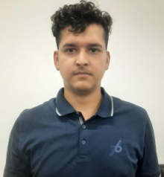

DR. KISHOR SHARMA

Assistant Professor

Pharm.D

Mata Gujri College of Pharmacy (Mata Gujri University)
Experience
- 1.3 Yr. Teaching
Research Interests
- Clinical Research
- Pharmacology
- Phytochemistry

Teaching Interests
- Phamacotherapeutics
- Pharmacy Practice
- Pharmaceutical Analysis
- Pharmacology
- Human Anatomy and Physiology

Poster presentation:
- 1 National

Seminar & Conference:
- 1 National

Contact Information
- Email: ks8906093549@gmail.com

Updated on: January 2026

